

Mobile Wallet Platform

## A BTL Go-to-Market Strategy Outline From Centrestage Marketing Ltd

Brief & Objective



Introduce the app to the target market.

Develop a BTL plan

Sign up both merchants and individual users.

BRIEF

OBJECTIVES

Increase brand love for Mo Change App

Increase download traffic within the target market

Convert TOM status into sales/uptake



Where are we?

Mo Change



Key Sell Key Partners Consumers

* New Product
* Great Product
* Great Name
* Meets Human Needs
* Coin Solution
* Coin Collection Partners (merchants)
* Coin Use

Partners (users)

* Multiple Users
* Key Savers

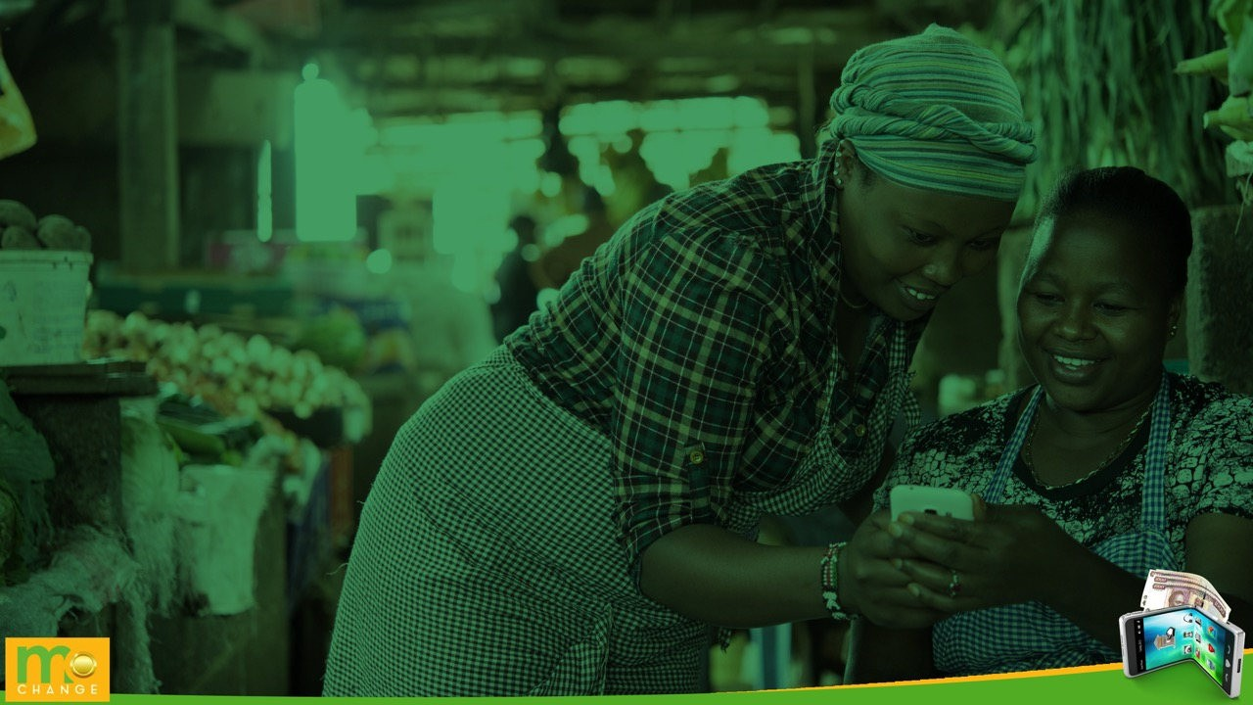

The Market Place

The Key Players



|  |  |  |
| --- | --- | --- |
| **Brand** | **Value Add** | **Attitude** |
| M-Pesa | Internal/external money transfer, airtime purchase (self/other), merchant payment, withdraw, loans, M-pesa global. | * Network strong countrywide   + Convenient     - Available       * Easy |
| Airtel Money | Internal/external money transfer, airtime purchase (self/other), merchant payment, withdraw, loans, M-pesa global. | * Poor Network |
| Telcom |  |  |
|  |  |  |

Brand usage decisions are based on the brand, experience, accesibility, aspiration, quality, image and price.

*To convert or recruit new consumers, a play on price during activations can make a significance difference.



The Target Market

The Store Owner (Merchant)

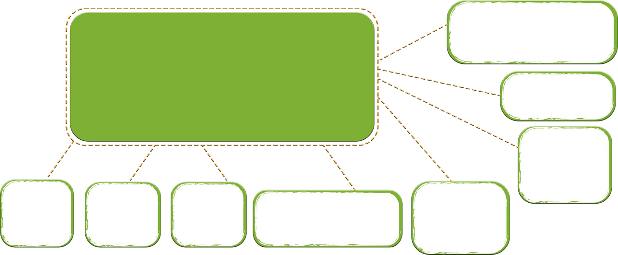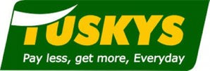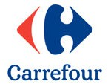

* + Fast Adopters – They want to set the trend in their areas.
  + Innovative – Find new ways to make money.
  + Find new ways to bring convenience to the end user.
  + Loves promotions and partnerships
  + Looking for the next big thing

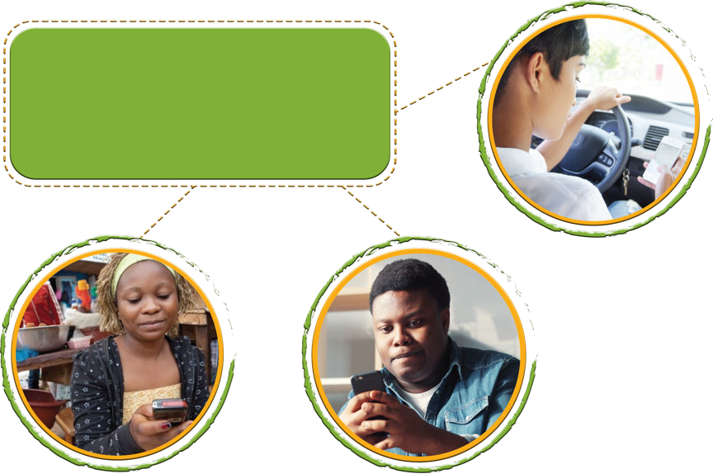The Consumer (User)

* + - Age 18-45
    - They love value add solutions.
    - They want convenient solutions.
    - They look for ways to save money.
    - Looking for the next big thing.



**Our Approach**

# How Do We Reach The Target Market?

#### Create a campaign that can translate on- ground

-How do we sign

up the merchant?

-How do we sign up the consumer?

-Where do we sign up the consumer?

**Set Mo Change apart in a way that has never been done before through an engaging recruitment drive.**

- What unique experience are we giving our TM?

**Incentives**

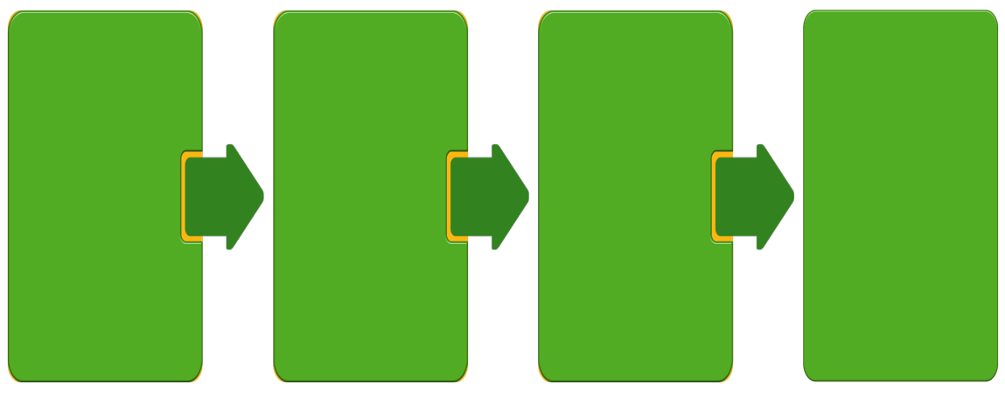-How do we Incentivize customers to use the Mo Change app?

-What value add

are we giving?

**Reward**

-What do we give as rewards for newly signed up customers?

Big Idea

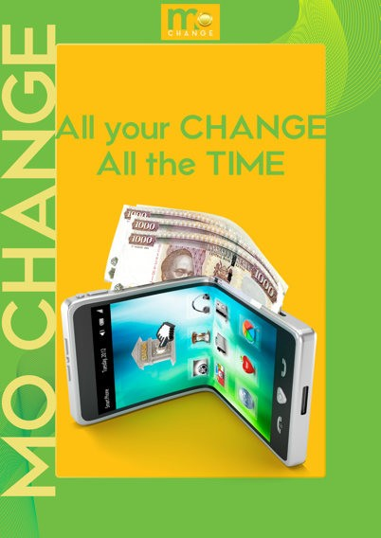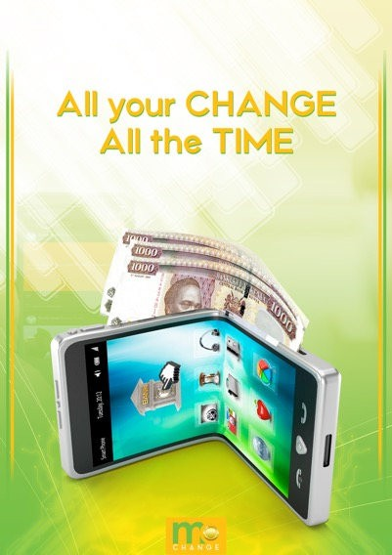



Execution

Merchant sign-up



* Mo Change’s role will be to have high level meetings with the decision makers for each outlet, with the aim to get approval to install the system in all their outlet till points.

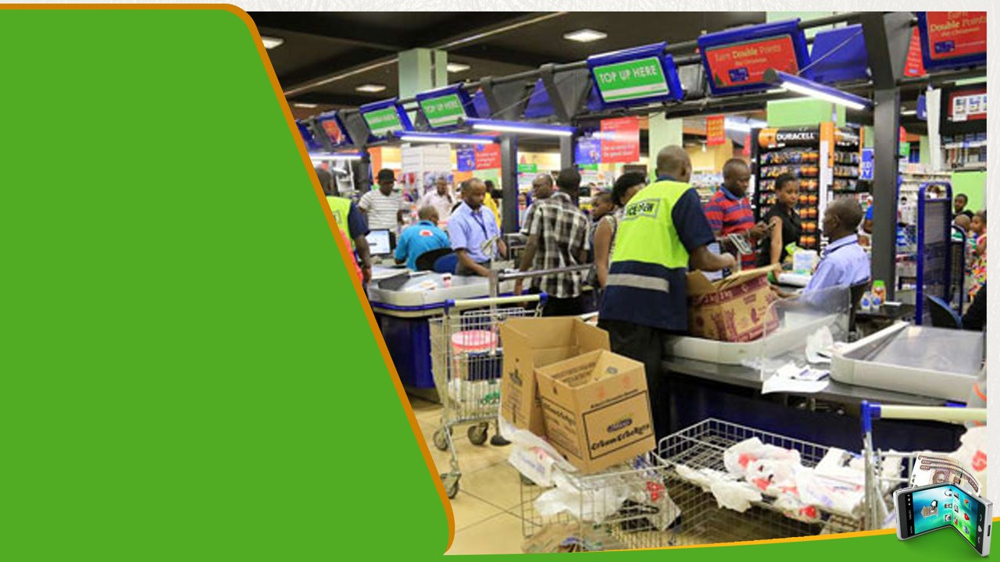

In-store

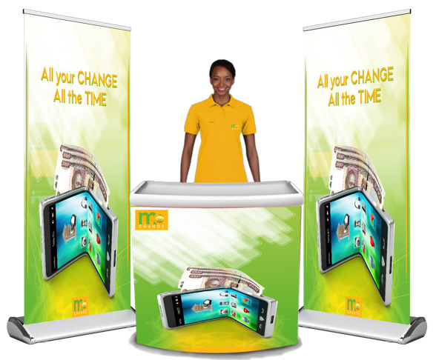Consumer sign-up



* 4 brand ambassadors outside the outlet
* Product introduction, education and demo
* Mo Change sign up
* Rewarding



*This sign-up process will be carried out for 4 days for the next two weeks in targeted stores. We propose providing WiFi at the setup to aid the process of customer registration.

Consumer Activation Walk Through

4 BA’s arrive at the outlet at 9 am.

Set Up to be fully complete

by 9.30 am BAs engage, educate

consumers and encourage them to download and register

Consumers that download are given a chance to lucky dip and win a branded merchandise depending on reward matrix

BAs activate through the morning and afternoon until 5pm



Full merchandise reconciliation to be done after activation ends.

- 6pm. This depends

with what time the outlet closes





Creating an activity that translates on-ground:

**Registration & Incentives**

We propose having 4 girls per store per day. 4 will be located outside the store standing next to a branded setup (with flyers and merchandise) engaging passerby's and customers going in and out of Tuskys. We propose the setup to have the information desk setup feel, where customers can have a sit as we take them through the product.

* The brand ambassadors will educate the customers on the product and its value add as they take them through the app.
* The customer will then be encouraged to download the app using the free WiFi provided at the setup and informed of the giveaways.
* The customers will be asked to deposit a minimum change of Kes. 50 into their Mo Change account after buying items at Tuskys for a chance to win merchandise through a lucky did mechanic.
* Each girl will have a target of 20 registrations per day.
* Our main goal to increase download traffic. However, it’s important to maintain the traffic and avoid having one-off users who only download and register to receive the giveaways. Therefore, we propose the following:





## Creating an activity that translates on-ground:

#### Continuity Of App Usage

* **Weekly Wins**
  + We propose weekly wins of Kes. 5,000 or a shopping voucher equivalent to the amount from the respective outlet, e.g. Tuskys.
  + Customers will be encouraged to use the app frequently to attract more points and stand a chance to win.
  + We propose Mo Change to send notifications and SMS blasts to existing customers, to notify them of the payments they can make via the app, weekly wins and how many more points they need to gain to stand a chance to win.

#### Cashier Rewards

* + To help push app usage, we propose awarding the merchant employees - the cashiers.
  + They interact with the customers as they make payment at the till, and they can easily suggest to customers to deposit their change into the their Mo Change account.
  + The cashiers will be rewarded based on how many deposits they have made each week.
  + We proposing branding the cashiers during this period.





## Creating an activity that translates on-ground:

### Other Ways To Promote App Usage

* **Awarding With Points On App**
  + Customers get XXXX points for every XXXX shillings used in the app.
  + They can then redeem the points to pay or buy other services within the app.
* **Discounts On App**
  + After using XXXX amount on the app, customers can get discounts codes which they can use to make payments to merchants on the app.
* **Rewarding Loyal Customers**
  + Loyal customers can be rewarded with money/ more points/Mo Change membership card which has value.

Activation Plan

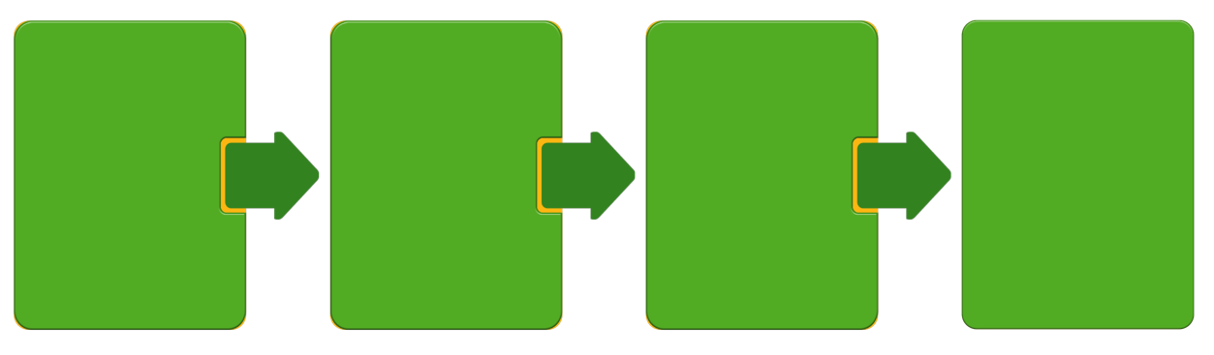CSM will recruit brand ambassadors who will start signing up consumers once outlet approvals are confirmed and communicated.

The BAs will then be trained internally and given all the material needed to aid with the sign-ups. This includes; Company tags, business cards, branded uniforms, sign up stationary etc.

We will start with **60 outlets** countrywide, working with **75 Bas** in total. Five outlets will have 2 Bas, while the rest have 1.

Regions - Nairobi, Western, Mombasa and Mountain

Sign-up Plan

* Team involved: **Brand ambassadors & Supervisors per region.**
* BAs will be allocated recruitment areas per their region.
* They will target to sign-up 20 users per day during the recruitment phase.
* They will have an incentive plan that will encourage consumers to sign-up to the app.
* They shall work closely with Mo Change.



Parking lots & office parks

# Registration

### Office Parks

* + Our team will meet with HR personnel from different offices and agree on when to meet their employees.
  + The employees will be educated about the product and convinced to download and sign up for Mo Change by our branded BAs.
  + They will get a chance to participate in a lucky dip and win branded merchandise.

**Parking Lots**

* + One brand ambassadors standing next to a branded booth and pull up banner. Sign-up happens here.
  + Two BAs handing out flyers in the parking lot.
  + Product introduction and education
  + Mo Change sign up
  + Rewarding



*This sign-up process will be carried out for 4 days for the next two weeks in targeted stores. We propose providing WiFi at the setup to aid the process of customer registration.

Giveaways

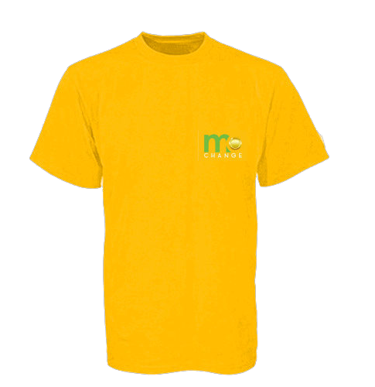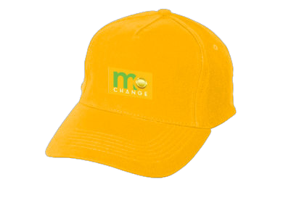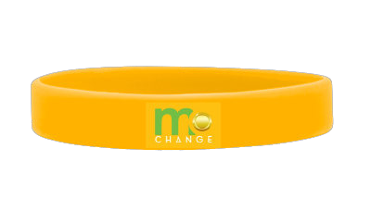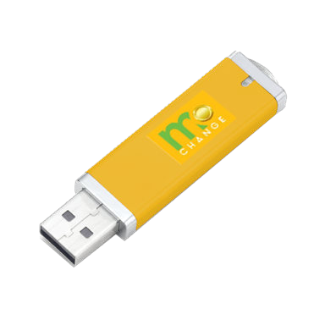

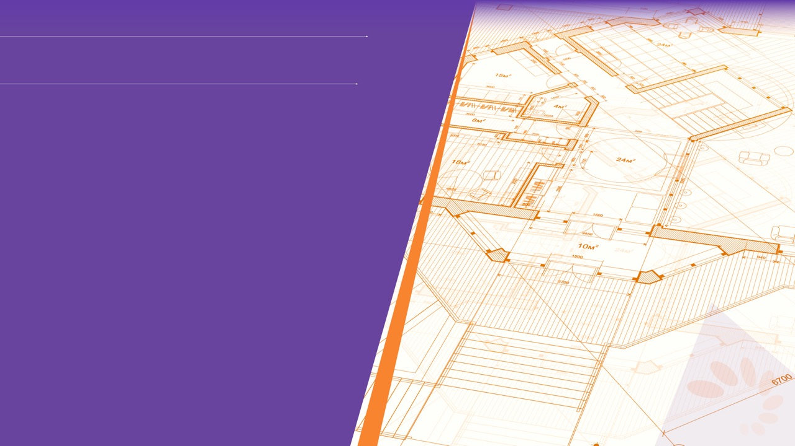**ABOUT CENTRESTAGE**

* Established in 2003, CentreStage Marketing is one of Kenya’s most exciting and innovative brand experience and event management companies
* We are passionate, dynamic, creative and reliable, offering the best experiential solutions. We deliver cost effectiveness and excellence that create client satisfaction and confidence
* We specialize in tailor-made solutions from event planning and management, experiential promotions, roadshows and on-the-go promotions to in-store promotions and product launches

# Why Us?



**EXPERIENCE** 14 years experience in this region – across

brands and categories **STRONG** on ground, hands on experience across key market **EXCELLENT** operating systems, procedures and feedback

mechanisms

**GOOD RELATIONSHIP** with the government and relevant

authorities

**SECURE** strong financial base with ability to undertake projects

that require large capital outlay

**EXCELLENCE** this is our core business. We do it well

   







**VARCITY SOCIAL**

**VARCITY PORTAL**

Student community of 30,000, news & update source

Anchor of Varcity brand Averages 10000 hits a month

**VARCITY NEWSLETTER**

**CAMPUS EVENTS**

Weekly email with the week’s highlights to subscriber list of 500

Partnerships with clubs, event teams and student leadership

Over 80,000 reached

**VARCITY AMBASSADORS**

**VARCITY BRAND ACTIVATIONS**

Tailor-made packages for on-campus brand activations.

Huawei Youth Campaign

| Cadbury | Palmolive | Weetabix

Access to database of 80 key influencers scattered across major campuses

**VARCITY APP**

News straight to your device the second it’s out

MEET VARCITY

A vibrant, online youth brand targeted at the 18-24 demographic with a core focus on university students.

Varcity connects with the youth through our various platforms, equipping them with knowledge, providing information and news updates and creating a positive environment for interaction and self-expression.

INTELLECTUAL COPYRIGHT

Centrestage Marketing retains the rights to all material contained in this presentation and in any presentation made in competition with, or in isolation from any other agency, in the event of our presentation being unsuccessful

No part of any proposal submitted may be used by any third party or the client without prior written approval from Centrestage Marketing or any one of the Centrestage Marketing owned companies

**CONTACTS**

Centrestage Marketing P.O. Box: 51634 - 00200 NAIROBI, KENYA

Cell: +254 724574575

Othaya Road, Gate No. 25 Web: [www.centrestage.co.ke](http://www.centrestage.co.ke/)

Email: [keziah.ndirangu@centrestage.co.ke](mailto:keziah.ndirangu@centrestage.co.ke)





THANK YOU

